Risk Management
&

Analysis Records

Issue Date: 27 / 12/ 2017 | Risk Management & Analysis
Issue / Revision No: R0 | Records
Page 2 of 13

Sana Pharmaceutical research Co. Ltd., Steering Committee, have reviewed the different guidelines as ISO 14971:2007 and then decides to do the following as risk management for DFC cream.

Section. 1 Definitions (according to ISO 14971:2007):

Concept | Definitions
Harm | physical injury or damage to the health of people, or damage to
 | property or the environment
Hazard | potential source of harm
Hazardous | circumstance in which people, property, or the environment are
situation | exposed to one or more hazard(s)
Risk | Combination of the probability of occurrence of harm and the
 | severity of that harm.
Risk analysis | Systematic use of available information to identify hazards and to
 | estimate risks.
Safety | Freedom from unacceptable.
Severity | Measure of the possible consequences of a hazard.

Section. 2 People that have participated in the realization of the present risk analysis:

In the realization of this analysis following people have intervened,

Quality Manager/ Technical Manager: Samer Al-Najjar

Quality Assurance Supervisor: Anas Awad

Production Manager: Abdullah Al-Najjar

Marketing Director: Nariman Saffarini

Section 3 Identification of the Qualitative and Quantitative characteristics:

User | Charge doctor, Nurse, patient
The user’s formation | Patient with muscle & joint pain
Environment | Home, office, outdoors or in hospital
Special users | Children or paralyzed patient.
In contact with patient | Yes
Used material | Aqua, Honey, Olea Europeae, Fruit oil, Propylene Glycol,
 | Arginine Hydrochloride, Ceteareth-20, Sorbitan Laurate,
 | Cetostearyl Alcohol, Isopropyl Myristate, PEG-6 Stearate,
 | Glycol Stearate, PEG-32 Stearate, Urea, White Petrolatum,
 | Imidazolidinyl Urea.
Given substance and | It doesn’t proceed.
biological material tried

Issue Date: 27 / 12/ 2017 |  |  | Risk Management & Analysis
Issue / Revision No: R0 |  |  | Records
Page 3 of 13
 | by the product
 | Sterilization |  | It doesn’t proceed. The product is non-sterile.
 | Susceptibility to |  | The product is given in a non-sterile state packed inside a
 | influences of the |  | container designed to protect the product from the
 | environment |  | environment during 3 years under the normal conditions of
 |  |  | storage. Bad storage conditions or bad manipulation of the
 |  |  | container may cause an injury of the product.
 | Fungible or essential |  | It doesn’t proceed. The product is supplied within a tube and
 | accessories to product |  | neither has fungible parts no need any accessories.
 | Limitation in the useful |  | The product is for multiple uses. Their useful life is limited at
 | life |  | the time from its packing until its period of use with a limit of 3
 |  |  | years.
 | Slowed secondary |  | It doesn’t proceed. The product is of transient use. The
 | effects associated to |  | experience with the product has demonstrated that they
 | the lingering use |  | don’t produce long term secondary effects.
 | Factors that determine |  | The limit of validity of the product is determined in a
 | period of product |  | predominant way by the protective container. Under normal
 | validity |  | storage conditions, it is guaranteed that this container
 |  |  | protects the product during 3 years.
 | A single use / re- |  | The product is for multiple uses.
 | utilizable

Section 4 Identification of the possible hazards and estimate of relative risks to each hazard:

In this step we identify the possible hazards associated to the product and we evaluate and estimate the relative risk to each hazard by the means of the consideration of the probability of the hazard and the severity of the same one once happened. The hazard of a product is inherent to its technology although this risk is naturally minimized in its design and production.

The probability and the severity are coded according to the following table.

1. Classification probability hazard
Indicator | Probability | Significance
Classification | Probability | Significance
6 | Frequent | Probability of big occurrence
5 | Occasional | It can happen several times in the life of the
5 | Occasional | system
4 | Reasonably | It can happen at some times in the life of the
4 | remote | system
3 | Remote | Unlikely occurrence, but possible
2 | Extremely | Occurrence probability spreading to zero
2 | remote | Occurrence probability spreading to zero
1 | Physically | Impossibility of the occurrence under
1 | impossible | conditions

Issue Date: 27 / 12/ 2017 |  |  | Risk Management & Analysis
Issue / Revision No: R0 |  |  |  | Records
Page 4 of 13
 |  |  | 2. Classification severity hazard
 | Indicator |  | Severity | Significance
 | Classification
 | IV 4 | Catastrophic |  | It can cause death or lost of the product
 | III 3 |  | It criticizes | It can cause severe lesion or severe injury of
 | III 3 |  | It criticizes | the product
 | II 2 |  | Marginal | It can cause smaller lesions or injuries
 | II 2 |  | Marginal | smaller than the product
 | I 1 | Insignificant |  | There is neither injury to the patient nor
 | I 1 |  |  | injuries to the product

N.B for the stage of Identification of risk, they are used:
  - The knowledge and the own experience

  - The applicable norms

- Risk analysis checklist (according to ISO 14971:2007)

# AP | Hazard | Prob. Sev. | Comments
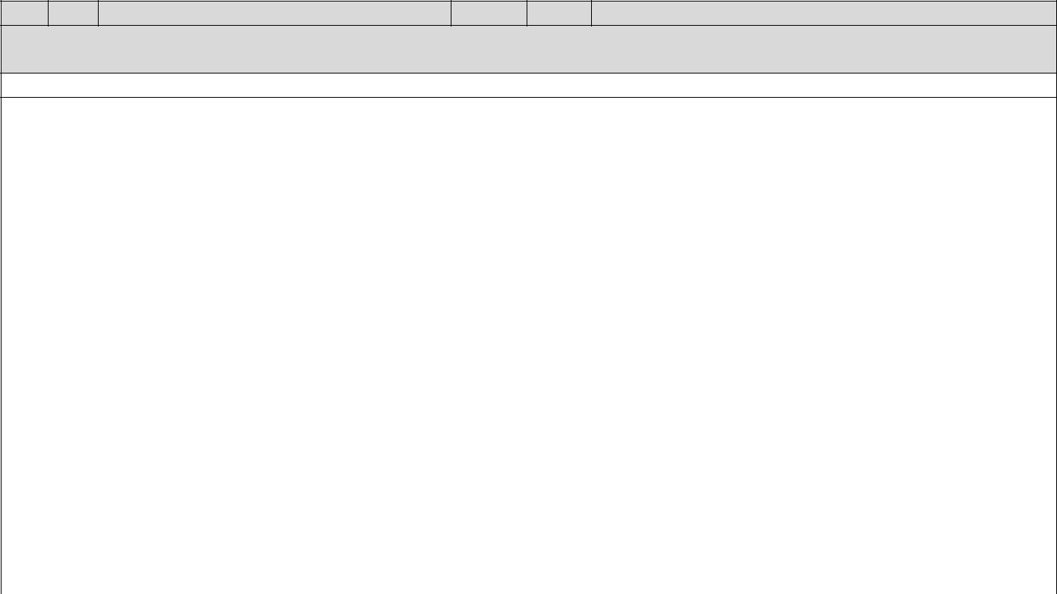
You notice: AP = applicability is in hazard, S = if, I am in hazard applicable, N = no, I am not in hazard,

- = Correlative number of the hazard, Prob. = probability, Sev. = Severity Relative hazard to the energy

Hazard of Biological and chemical nature
 | 1. | S |  |  |  |  |  |  | Through the manufacturing process
 |  |  |  |  |  |  |  |  | microbiological control is employed to
 |  |  | Biological contamination |  |  |  | 2 | II | maintain the microbiological |  | specification
 |  |  |  |  |  |  | 2 | II | within the limit. The product is packed in a
 |  |  |  |  |  |  |  |  | sealed tube that prevents contamination of
 |  |  |  |  |  |  |  |  | product through storage.
 | 2. | S |  |  |  |  |  |  | The used raw materials are biocompatible.
 |  |  | Biological incompatibility |  |  |  | 2 | II | They are considered remote the possibilities
 |  |  |  |  |  |  | 2 | II | to cause due affections to the
 |  |  |  |  |  |  |  |  | biocompatibility.
 | 3. | S |  |  |  |  |  |  | As device is classified as |  | non-invasive
 |  |  | Cross Infection |  |  |  | 2 | II | device, It could not be a |  | source of
 |  |  |  |  |  |  |  |  | contamination.
 | 4. | S |  |  |  |  |  |  | The chemical composition of the raw
 |  |  |  |  |  |  |  |  | materials used during the manufacturing
 |  |  | Incorrect formulation (chemical |  |  |  |  |  | process of the device is stable, unchanged.
 |  |  |  |  |  |  | 2 | II | Extensive inspections are made for the raw
 |  |  | composition) |  |  |  | 2 | II
 |  |  |  |  |  |  |  |  | materials chemical composition from the
 |  |  |  |  |  |  |  |  | stage of their incoming and into the final
 |  |  |  |  |  |  |  |  | manufacturing stage takes place.
Issue Date: 27 / 12/ 2017 |  |  |  |  |  | Risk Management & Analysis
Issue / Revision No: R0 |  |  |  |  |  | Records
Page 5 of 13
 | # AP |  |  | Hazard |  | Prob. Sev. |  |  |  | Comments
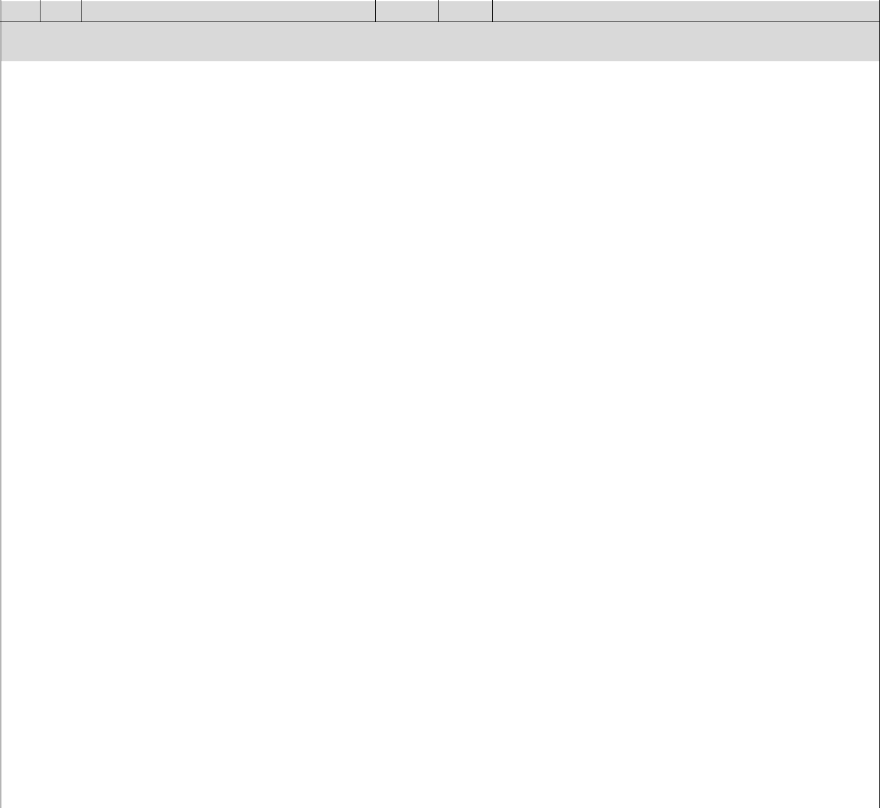
You notice: AP = applicability is in hazard, S = if, I am in hazard applicable, N = no, I am not in hazard,
- = Correlative number of the hazard, Prob. = probability, Sev. = Severity

5. | S |  |  |  |  |  | The product is composed of: Aqua, Honey,
 |  |  |  |  |  |  | Olea Europeae, Fruit oil, Propylene Glycol,
 |  |  |  |  |  |  | Arginine |  | Hydrochloride, |  |  |  |  | Ceteareth-20,
 |  |  |  |  |  |  | Sorbitan | Laurate, |  |  |  | Cetostearyl |  |  |  | Alcohol,
 |  |  |  |  |  |  | Isopropyl Myristate, PEG-6 Stearate, Glycol
 |  |  |  |  |  |  | Stearate, PEG-32 Stearate, Urea, White
 |  | Degradation |  | 3 | III |  | Petrolatum, Imidazolidinyl Urea, which are
 |  | Degradation |  | 3 | III |  | not susceptible to a significant degradation
 |  |  |  |  |  |  | during the useful life time of the product. The
 |  |  |  |  |  |  | product is packed in a container designed to
 |  |  |  |  |  |  | protect | its |  | content. |  |  | Condition |  |  | adverse
 |  |  |  |  |  |  | storage or manipulation can cause the
 |  |  |  |  |  |  | degradation of the container with lead to
 |  |  |  |  |  |  | product contamination.
6. | S |  |  |  |  |  | The toxicity for components, raw materials
 |  | Toxicity |  | 2 | II |  | and assembled |  |  |  | sterilized |  |  | products were
 |  | Toxicity |  | 2 | II |  | conducted as a part of biocompatibility
 |  |  |  |  |  |  | analysis.
7. | N | Pyrogenicity |  | - | - |  | The product |  |  | is | non-pyrogenic which |  |  |  |  |  | was
 |  | Pyrogenicity |  | - | - |  | confirmed |  | by |  | the | biocompatibility |  |  |  |  | test
 |  |  |  |  |  |  | conducted.
8. | S | Inability of maintaining the |  | 2 | II |  | The absence |  |  | of | appropriate |  |  |  | conditions of
 |  | Inability of maintaining the |  | 2 | II |  | hygiene | when opening |  |  |  |  | the |  | product |  | can
 |  | hygienic safety |  | 2 | II
 |  | hygienic safety |  |  |  |  | cause the contamination of the product.
Environmental Hazard
9. | S |  |  |  |  |  | The product can be used in a variety of
 |  |  |  |  |  |  | environments including out door. No special
 |  |  |  |  |  |  | environment is required for the use of
 |  | Likelihood of operation outside |  |  |  |  | product. | To |  | use |  | The |  | product |  | in | an
 |  | Likelihood of operation outside |  |  |  |  | atmosphere in the one which the conditions
 |  | prescribed environmental |  | 2 | II
 |  | prescribed environmental |  | 2 | II |  | of cleaning |  | and |  | hygiene |  |  | are | scarce, |  | the
 |  | condition
 |  | condition |  |  |  |  | possibilities increase of contaminating the
 |  |  |  |  |  |  | product during their extraction of the
 |  |  |  |  |  |  | container before their use in the patient but it
 |  |  |  |  |  |  | won’t affect their physical properties.
10. | S | Accidental mechanical damage |  |  |  |  | The loss | of |  | mechanical |  |  |  | integrity |  | of | the
 |  | Accidental mechanical damage |  | 3 | III |  | product | container |  |  |  | can |  |  | causes |  | the
 |  | (injury) |  | 3 | III |  | product |  |  |  |  |  |  |  |  |  | the
 |  | (injury) |  |  |  |  | contamination of the product.

Issue Date: 27 / 12/ 2017 |  |  |  | Risk Management & Analysis
Issue / Revision No: R0 |  |  |  | Records
Page 6 of 13
 | # AP | Hazard |  | Prob. Sev. | Comments

You notice: AP = applicability is in hazard, S = if, I am in hazard applicable, N = no, I am not in hazard,
- = Correlative number of the hazard, Prob. = probability, Sev. = Severity

11. | S |  |  |  |  |  | The product form will not support spore
 |  |  |  |  |  |  | germination or microbial growth due to their
 |  |  |  |  |  |  | low water activity. Microbial contamination
 |  |  |  |  |  |  | of the raw materials, ingredient water,
 |  |  |  |  |  |  | manufacturing | process, |  | formulation, and
 |  |  |  |  |  |  | packaging system is controlled. The testing
 |  | Contamination due to waste |  |  |  |  | history would include microbial monitoring
 |  | Contamination due to waste |  |  |  |  | during product development, |  |  |  |  | scale-up,
 |  | products and /or device disposal |  | 3 | III |  |  |  |  |  |  | scale-up,
 |  | products and /or device disposal |  | 3 | III |  | process validation, and routine testing of
 |  |  |  |  |  |  | sufficient marketed product lots to ensure
 |  |  |  |  |  |  | that the product has little or no potential for
 |  |  |  |  |  |  | microbial contamination. It will not be a
 |  |  |  |  |  |  | source of biological contamination as it will
 |  |  |  |  |  |  | not be in contact with patient biological
 |  |  |  |  |  |  | fluids. It doesn’t need any special disposal
 |  |  |  |  |  |  | method.
tive | Hazard | to operational
12. | S | Use by unskilled/ untrained |  | 1 | I |  | The product needs neither special skills nor
 |  | Use by unskilled/ untrained |  | 1 | I |  | training for its usage.
 |  | personnel |  | 1 | I
13. | S |  |  |  |  |  | The misuse of the device will not cause any
 |  |  |  |  |  |  | severe injury to the patient. The instruction
 |  | Reasonably foreseeable misuse |  | 2 | I |  | for use which is indicated in the label and the
 |  | Reasonably foreseeable misuse |  | 2 | I |  | leaflet includes indication for all needed data
 |  |  |  |  |  |  | to decrease the possibilities of misuse to
 |  |  |  |  |  |  | take place.
14. | S | Incompatibility with |  |  |  |  | Not applicable. The product is not dedicated
 |  | consumable/accessories/other |  | - | - |  | to be connected with other device.
 |  | devices
Relative Hazard to information
15. | S |  |  |  |  |  | There is adequate labeling for indications
 |  |  |  |  |  |  | and directions , it also includes a caution not
 |  |  |  |  |  |  | to use the product over open wounds, this
 |  | Inadequate labeling |  | 2 | II |  | will decrease | the | risk | of | the | patient’s
 |  | Inadequate labeling |  | 2 | II |  | infection, other cautions that is included ; for
 |  |  |  |  |  |  | external use only, keep out of reach of
 |  |  |  |  |  |  | children , avoid eye contact and do not use if
 |  |  |  |  |  |  | seal or tube is injured or damaged
16. | S |  |  |  |  |  | There is a com plete information stated in the
 |  |  |  |  |  |  | instruction for use to avoid misuse of the
 |  | Incomplete instruction for use |  | 2 | II |  | product. The instruction for use of the device
 |  | Incomplete instruction for use |  | 2 | II |  | meets the requirements of the directive
 |  |  |  |  |  |  | 93/42/EEC and obligatory standard of the
 |  |  |  |  |  |  | product.
17. | S | Inadequacy description of |  |  |  |  | It is clearly stated to the user the intended
 |  | Inadequacy description of |  |  |  |  | use of the device on the label and in the
 |  | performance characteristics for |  | 2 | II
 |  | performance characteristics for |  | 2 | II |  | instruction for | use | manual |  | which | supplied
 |  | the intended use
 |  | the intended use |  |  |  |  | with the device.
18. | S |  |  |  |  |  | The basic indications are included for
 |  | Inadequate operating instruction |  | 2 | II |  | correct use of the product. The cautions for
 |  | Inadequate operating instruction |  | 2 | II |  | correct manipulation and storage of the
 |  |  |  |  |  |  | product.

Issue Date: 27 / 12/ 2017 |  |  |  | Risk Management & Analysis
Issue / Revision No: R0 |  |  |  | Records
Page 7 of 13
 | # AP | Hazard |  | Prob. Sev. | Comments
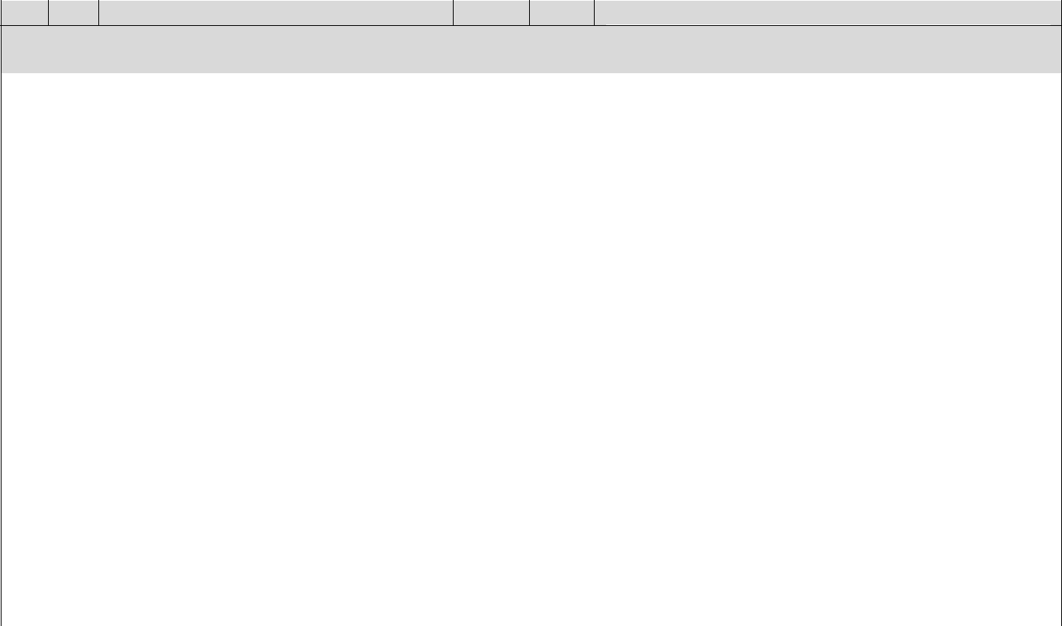
You notice: AP = applicability is in hazard, S = if, I am in hazard applicable, N = no, I am not in hazard,
- = Correlative number of the hazard, Prob. = probability, Sev. = Severity

19. | S | Inadequate specification of pre- |  | 2 | II |  | The integrity of the protective container and
 |  | use checks |  | 2 | II |  | seal will be verified before opening up.
20. | S | Over complicated operating |  |  |  |  | The basic | indications | are included | in | the
 |  | Over complicated operating |  | 2 | II |  | instruction | for use for | correct use | of | the
 |  | instruction |  | 2 | II
 |  | instruction |  |  |  |  | product.
21. | S | Unavailable or separated |  | 2 | II |  | The basics indications are included for the
 |  | operating instruction |  | 2 | II |  | correct use of the product.
22. | N | Insufficient warning of side |  | - | - |  | Not applicable.
 |  | effects |  | - | -
23. | N | Inadequate warning of hazards |  |  |  |  | The product is for multiple uses.
 |  | likely with re-use of single use |  | - | -
 |  | devices
Hazards arising from functional failure maintenance and ageing
24. | S | Lack of adequate determination |  | 3 | II |  | The inadequacy of the date of expiration
 |  | Lack of adequate determination |  | 3 | II |  | could cause the use of the product while it
 |  | of end device life |  | 3 | II
 |  | of end device life |  |  |  |  | has lost part or all of its activity.
25. | S | Loss of mechanical integrity |  | 2 | II |  | The loss of mechanical integrity of the
 |  | Loss of mechanical integrity |  | 2 | II |  | product container can causes the
 |  |  |  |  |  |  | contamination of the product.
26. | S | Inadequate packaging |  |  |  |  | A non-appropriate container may lead to the
 |  | (contamination and/ or |  | 2 | II |  | contamination of the product
 |  | deterioration of the device)
27. | N | Improper re-use |  | - | - |  | The product is for multiple uses.

Section. 5 Acceptability of the Risk

Of the previous chart, we will establish a summary by means of the map of distribution of the same ones in the chart of your limit of acceptable of the risk.

The distribution of the acceptability areas and of non acceptability of the risk they have settled down with the approach that not serious acceptable all risk that could cause a serious incident in the patient y/o user. The area ALARP has settled down based on the experience.

Let us see the summary of the risks in the chart:
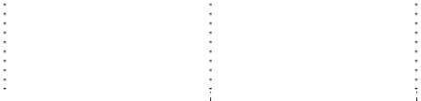
 | Frequent
 | (6)
 | Occasional
 | (5)
Probability | Reasonably
Probability | remote
Probability | (4)
Probability | Remote |  |  |  |  | 24 |  |  | 5, 10, 11
Probability | (3) |  |  |  |  | 24
 | Extremely |  |  | 1, 2, 3, 4, 6, 8,
 | Extremely |  |  | 9, 15, 16, 17,
 | remote | 13
 | remote | 13 |  | 18, 19, 20, 21,
 | (2)
 | (2) |  |  | 25, 26
 | Impossible | 12
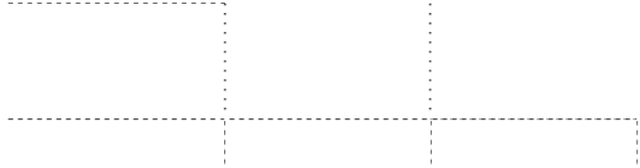
Issue Date: 27 / 12/ 2017 |  |  |  | Risk Management & Analysis
Issue / Revision No: R0 |  |  |  |  |  | Records
Page 8 of 13
 |  | (1) |  | Insignificant |  |  | Marginal |  | Critic |  | Catastro phic
 |  |  |  | (I) |  |  | (II) |  | (III) |  | (IV)
 |  |  |  |  |  |  | Severity

Un acceptable risk | Risk “ALARP” | Acceptable Risk

Section. 6 Reduction of the risk

For the unacceptable / ALARP risk, we can control those risks by the following three ways listed (according to ISO 14971):

- Inherent safety by design (design measure of control).

- Protective measures in the product itself or in the manufacturing process (Protective measure of control).

- Information for safety (Information measure of control).

# |  | Type of hazard |  |  |  | Incorrect formulation (Chemical Composition)
18 |  | Area initial risk |  | ALARP Risk "As low as reasonable practiced" (P= 3; S=III)
 |  | Ways of control |  | Design and protective measures.
 |  | Methods of |  |  | As method of design control, the manufacturing process takes place by
 |  | control |  |  | using material of stable, unchanged chemical composition (i.e. during the
 |  |  |  |  | manufacturing processes taking place, there is no change occur in the
 |  |  |  |  | chemical composition of the raw material used), in which it doesn’t affect
 |  |  |  |  | the patient. As method of protective measures, extensive checks are
 |  |  |  |  | made for the composition & concentration of raw materials used in the
 |  |  |  |  | manufacturing process of the device from the stage of their incoming into
 |  |  |  |  | the company, and into the final production process of packaging of the
 |  |  |  |  | device.
 |  | Comments |  |  | By means of the adoption of these control method / reduction of the risk,
 |  |  |  |  | is considered that we reduce the probability of occurrence of that hazard
 |  |  |  |  | to be physically impossible "Impossibility of the occurrence under
 |  |  |  |  | conditions".
 |  | Final risk |  | Acceptable risk P=1, S=III
# |  | Type of hazard |  |  |  |  | Degradation
19 |  | Area initial risk | ALARP Risk "As low as reasonable practiced" (P=3; S=III)
 |  | Ways of control | Protective measures.
 |  | Methods of |  | As method of protective measures, The useful life of the product comes
 |  | control |  | determined by the limit of the period during which can make sure which
 |  |  |  | the container of the product protects its content. We have settled down
 |  |  |  | that this period is 3 years. The end of the period during which you can use
 |  |  |  | the product with complete safety is indicated in the label by means of the
 |  |  |  | normalized symbol and the date limit in year terms and month. The
 |  |  |  | stability of the product over 3 years period has been established through
 |  |  |  | accelerated stability study for 12 months at 40ºC/75 % RH.
 |  | Comments |  | It is considered that when including the date of expiration of the product
 |  |  |  | in the label, it reduces the probability that the product is used in the one
 |  |  |  | that degradation has taken place.
 |  | Final risk | Acceptable Risk P=1, S=III

Issue Date: 27 / 12/ 2017 |  |  |  |  | Risk Management & Analysis
Issue / Revision No: R0 |  |  |  |  |  |  | Records
Page 9 of 13
 | # | Type of hazard |  |  |  |  |  | Toxicity
 | 20 | Area initial risk |  | ALARP Risk "As low as reasonable practiced" (P= 3; S=II)
 |  | Ways of control |  | Protective measures
 |  | Methods of |  | As method of protective measures, Biocompatibility study takes place for
 |  | control |  | all components, raw material used in the manufacturing of the device
 |  |  |  | individually and assembled in the same device. The interaction of
 |  |  |  | manufacturing process also controlled.
 |  | Comments |  | It is considered that the adoption of these methods of control of the
 |  |  |  | toxicity of the biological contamination reduces the probability of its
 |  |  |  | occurrence to be physically impossible "Impossibility of the occurrence
 |  |  |  | under conditions".
 |  | Final risk |  | Acceptable Risk P=1, S=II
 | # | Type of hazard |  |  |  |  | Inability of maintaining the hygienic safety
 | 22 | Area initial risk | ALARP Risk "As low as reasonable practiced" (P=3; S=III)
 |  | Ways of control | Design, protective measures and information.
 |  | Methods of |  | As design measure, The product is designed to be oily gel with low water
 |  | control |  | activity. Presentation and keeping the device protective from the air,
 |  |  |  | tissues and environment exposure.. As information measure, we
 |  |  |  | incorporated to the container the normalized symbols that they indicate
 |  |  |  | the storage conditions and warning are indicated of not using the product
 |  |  |  | if the container has been injured or damaged. The instructions for use
 |  |  |  | which supplied with each device have an indication for its optimal usage
 |  |  |  | and a warning of not applying the product over open wounds and/or non
 |  |  |  | intact skin.
 |  | Comments |  | It is considered that when adopting these controls methods, we decrease
 |  |  |  | the probability of occurrence of this hazard.
 |  | Final risk | Acceptable Risk P=2, S=III
 | # | Type of hazard |  |  |  |  | Accidental mechanical damage (injury)
 | 27 | Area initial risk | ALARP Risk "As low as reasonable practiced" (P= 3; S=III)
 |  | Ways of control | Protective measures and information.
 |  | Methods of |  | As method of protective measures, it is packed in a container that
 |  | control |  | protects the content from environment and it can withstand normal
 |  |  |  | condition of storage, shipping and handling while keeping its mechanical
 |  |  |  | integrity. Also, as information method of control, it is included in the one
 |  |  |  | labeled of the product a warning so that the user doesn’t use the product
 |  |  |  | if the container has been injured or damaged.
 |  | Comments |  | The adoption of these control methods allows reducing the probability of
 |  |  |  | occurrence of this risk.
 |  | Final risk | Acceptable Risk P=2, S=III
 | # | Type of hazard |  |  |  |  |  | Inadequate operating instruction
 | 39 | Area initial risk | ALARP Risk "As low as reasonable practiced" (P=3; S=III)
 |  | Ways of control | Design and protective measures.
Issue Date: 27 / 12/ 2017 |  |  |  |  | Risk Management & Analysis
Issue / Revision No: R0 |  |  |  |  |  | Records
Page 10 of 13
 |  | Methods of |  | As way of design control, the instruction for use provided in the label and
 |  | control
 |  | control |  | in the leaflet together with the warning present in simplified way the user
 |  |  |  | with the proper method of product use. As way of protective measures of
 |  |  |  | control, we carried out a routine confirmation of the instruction for use to
 |  |  |  | meet the requirement of the recent international standards.
 |  | Comments |  | It is considered that the incorporation of these measures still reduces the
 |  |  |  | probability of occurrence of this risk in the absence or in the event of
 |  |  |  | inadequacy of the instruction that accompany to the product.
 |  | Final risk | Acceptable Risk P=2, S=III
 | # | Type of hazard |  |  |  | Lack of adequate determination of end device life
 | 48 | Area initial risk |  | ALARP Risk "As low as reasonably practiced" (P=3; S=II)
 |  | Ways of control |  | Design and protective measures
 |  | Methods of |  | As design method, In the design of the product, it is determine that the
 |  | control |  | useful life of the product comes limited by the useful life of the protective
 |  |  |  | container. The characteristics of the materials of the container allow
 |  |  |  | assigning a useful life of these of 3 years under normal condition of
 |  |  |  | storage.
 |  |  |  | As protective measures of control, for the control of the adaptation of the
 |  |  |  | assigned expiration, accelerated stability test of the product has been
 |  |  |  | conducted for 1 year at 40ºC/75 % RH. Furthermore retained samples of
 |  |  |  | every batch are retested for its stability once a year and until the expiry
 |  |  |  | date of the product.
 |  | Comments |  | The adoption of these control methods allows reducing the probability of
 |  |  |  | occurrence of this risk.
 |  | Final risk |  | Acceptable Risk P=2, S=III
 | # | Type of hazard |  |  |  |  |  | Loss of mechanical integrity
 | 49 | Area initial risk |  | ALARP Risk "As low as reasonable practiced" (P= 3; S=II)
 |  | Ways of control | Protective measures and information
 |  | Methods of |  | As protective measures of control, they are carried out an extensive
 |  | control |  | check for the effectiveness of the protective containers which protect the
 |  |  |  | content of the product.
 |  |  |  | Also, as information method, it is included in the one labeled of the
 |  |  |  | product a warning so that the user doesn’t use the product if the
 |  |  |  | container has been injured or damaged; also it is indicated in the leaflet.
 |  | Comments |  | The adoption of these control methods allows reducing the probability of
 |  |  |  | occurrence of this risk.
 |  | Final risk | Acceptable Risk P=2, S=II
 | # | Type of hazard |  | Inadequate packaging (contamination and / or deterioration of the device)
 | 50 | Area initial risk | ALARP Risk "As low as reasonably practiced" (P=3; S=II)
 |  | Ways of control | Design, protective measures and information

Issue Date: 27 / 12/ 2017 |  |  |  |  | Risk Management & Analysis
Issue / Revision No: R0 |  |  |  |  | Records
Page 11 of 13
 |  | Methods of |  | As design control, In the design of the product we settles down that the
 |  | control
 |  | control |  | materials of having packed will have the appropriate characteristics to
 |  |  |  | protect their contents (content specification) state during storage and
 |  |  |  | transport of the product throughout the product life as indicated by the
 |  |  |  | manufacture and expiry date (3 years).
 |  |  |  | The specification of the materials of the individual container and those of
 |  |  |  | the other packaging materials (i.e. secondary packaging and transport
 |  |  |  | packaging) are all documented and they are conserved in the technical
 |  |  |  | file of the product.
 |  |  |  | As protective measures, we carried out controls for the effectiveness of
 |  |  |  | the individual container and samples of each lot of manufactured product.
 |  |  |  | As information measures, The product label indicates a warning that the
 |  |  |  | user doesn’t use the product if the individual container has been injured
 |  |  |  | or damaged; also it is included in the leaflet.
 |  | Comments |  | The adoption of these control methods allows reducing the probability of
 |  |  |  | occurrence of this risk.
 |  | Final risk | Acceptable Risk P=2, S=II

Section. 7 Generation of other hazards

The methods of reduction of the established risks have been revised to determine that new risks have not been generation. The analysis of the non- conformities and incidence that you/ they can appear in the intensive operation of the team for our clients will give us in their case rules to verify that this analysis is correct.

Section. 8 Evaluation of all the identified hazards

We have carried out an exhaustive revision of the hazards that you/ they can associate to the product and therefore they are considered evaluated all the risks of the product according to the summery of the following table.

 |  |  |  |  |  |  |  |  |  | Way |  |  |  |  | Other risks |  | Final
 | # |  |  | Hazard |  |  | Risk initial |  |  | Way |  |  | Final risk |  | have been |  | Final
 | # |  |  | Hazard |  |  | Risk initial |  |  | control |  |  | Final risk |  | have been |  | evaluation
 |  |  |  |  |  |  |  |  |  | control |  |  |  |  | generated |  | evaluation
1 |  |  |  | Biological contamination |  | acceptable |  |  |  |  |  |  | acceptable |  | No |  | ok
2 |  |  | Biological Incompatibility |  |  |  | acceptable |  |  |  |  |  | acceptable |  | No |  | ok
3 |  |  | Cross Infection |  |  | acceptable |  |  |  |  |  |  | acceptable |  | No |  | ok
4 |  |  |  | Incorrect formulation |  |  | acceptable |  |  |  |  |  | acceptable |  | No |  | ok
 |  |  |  | (Chemical Composition)
5 |  |  |  | Degradation |  |  | ALARP |  |  | Protective |  |  | Acceptable |  | No |  | ok
 |  |  |  |  |  |  |  |  |  |  |  |  | Risk P=3,
 |  |  |  |  |  |  |  |  |  | measures
 |  |  |  |  |  |  |  |  |  |  |  |  | S=III
6 |  |  | Toxicity |  |  |  | acceptable |  |  |  |  |  | acceptable |  | No |  | ok
8 |  |  | Inability of maintaining |  |  | acceptable |  |  |  |  |  |  | Acceptable |  | No |  | ok

Issue Date: 27 / 12/ 2017 |  |  |  |  |  |  | Risk Management & Analysis
Issue / Revision No: R0 |  |  |  |  |  |  |  |  | Records
Page 12 of 13
 |  |  |  |  |  |  |  |  |  |  |  | Way |  |  |  |  |  | Other risks |  | Final
 |  | # |  |  | Hazard |  |  |  | Risk initial |  |  | Way |  |  | Final risk |  |  | have been |  | Final
 |  | # |  |  |  |  |  |  | Risk initial |  |  | control |  |  |  |  |  | have been |  | evaluation
 |  |  |  |  |  |  |  |  |  |  |  | control |  |  |  |  |  | generated |  | evaluation
 |  |  |  |  | the hygienic safety
 |  |  |  |  | Likelihood of operation |  |  |  |  |  |  |  |  |  |  |  |  | No |  | ok
 | 9 |  |  |  | outside prescribed |  |  |  | acceptable |  |  |  |  |  | acceptable
 |  |  |  |  | environmental condition
 | 10 |  |  |  | Accidental mechanical |  |  |  |  |  |  | Protective |  |  | Acceptable |  |  | No |  | ok
 |  |  |  |  |  |  |  |  | ALARP |  |  | measures, |  |  | Risk P=3,
 |  |  |  |  | damage (injury)
 |  |  |  |  |  |  |  |  |  |  |  | information |  |  | S=III
 |  |  |  |  | Contamination due to |  |  |  |  |  |  | Protective |  |  | Acceptable |  |  | No |  | ok
 | 11 |  |  |  | waste products and /or |  |  |  | ALARP |  |  | measures, |  |  | Risk P=3,
 |  |  |  |  | device disposal |  |  |  |  |  |  | information |  |  | S=III
 | 12 |  |  |  | Use by unskilled/ |  |  |  | acceptable |  |  |  |  |  | acceptable |  |  | No |  | ok
 |  |  |  |  | untrained personnel
 | 13 |  |  |  | Reasonably foreseeable |  |  |  | acceptable |  |  |  |  |  | acceptable |  |  | No |  | ok
 |  |  |  |  | misuse
 | 15 |  |  | Inadequate labeling |  |  |  | acceptable |  |  |  |  |  |  | acceptable |  |  | No |  | ok
 | 16 |  |  |  | Incomplete instruction |  |  |  | acceptable |  |  |  |  |  | acceptable |  |  | No |  | ok
 |  |  |  |  | for use.
 |  |  |  |  | Inadequacy of |  |  |  |  |  |  |  |  |  |  |  |  | No |  | ok
 | 17 |  |  |  | performance |  |  |  | acceptable |  |  |  |  |  | acceptable
 |  |  |  |  | characteristics for the
 |  |  |  |  | intended use
 | 18 |  |  |  | Inadequate operating |  |  |  | acceptable |  |  |  |  |  | acceptable |  |  | No |  | ok
 |  |  |  |  | instruction
 | 19 |  |  |  | Inadequate specification |  |  |  | acceptable |  |  |  |  |  | acceptable |  |  | No |  | ok
 |  |  |  |  | of pre-use checks
 | 20 |  |  |  | Over complicated |  |  |  | acceptable |  |  |  |  |  | acceptable |  |  | No |  | ok
 |  |  |  |  | operating instruction
 | 21 |  |  |  | Unavailable or separated |  |  |  | acceptable |  |  |  |  |  | acceptable |  |  | No |  | ok
 |  |  |  |  | operating instruction
 |  |  |  |  | Lack of adequate |  |  |  |  |  |  | Design , |  |  | Acceptable |  |  | No |  | ok
 | 24 |  |  |  | determine of end device |  |  |  | ALARP |  |  | Protective |  |  | Risk P=3,
 |  |  |  |  | life |  |  |  |  |  |  | measures |  |  | S=II
 | 25 |  |  |  | Loss of mechanical |  |  |  | acceptable |  |  |  |  |  | acceptable |  |  | No |  | ok
 |  |  |  |  | integrity
 |  |  |  |  | Inadequate packaging |  |  |  |  |  |  |  |  |  |  |  |  | No |  | ok
 | 26 |  |  |  | (contamination and/ or |  |  |  | acceptable |  |  |  |  |  | acceptable
 |  |  |  |  | deterioration of the
 |  |  |  |  | device)

Section. 9 Adaptation of the safety of the product

When carrying out a revision of the previous table it is considered that the identified and the associate risks have decreased at reasonable and acceptable levels. It is considered then verified the safety of the product “Stopain plus”.
Issue Date: 27 / 12/ 2017 |  | Risk Management & Analysis
Issue / Revision No: R0 |  | Records
Page 13 of 13
Section. 10 Conclusions:

Starting from the result of the pervious table we can conclude because that the product is safe as much for its design as for its production and it is then capable for its setting in the market.

Results of the analysis | Capable
Results of the analysis | □ Not Capable
Section. 11 Changes and Revision:

When having any modification in the design of the product, when being published new applicable harmonized norms to the same one or the technologies used for their production or before the appearance of new data that you/ they can affect the evaluation of the risks, we will be carried out a revision of the present analysis to determine if they are had increasing or diminished the risks or if can be identified according to the procedure of control of changes.

